1. The characteristics of EEG for drowsiness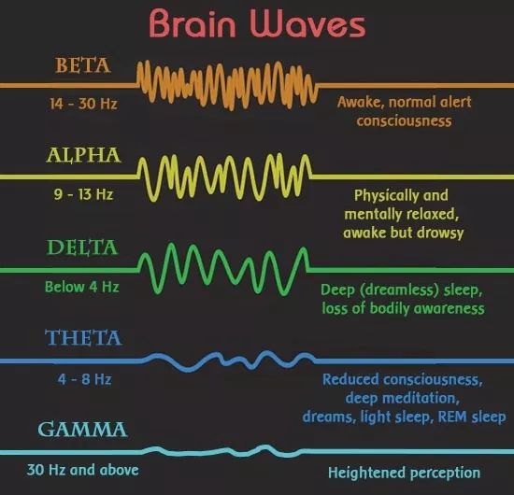

1) wave (8-13 Hz): gradual or rapid dropout

2) wave (4-8 Hz): appear

3) wave (14-30Hz): reduce, could be mixed with other bands for calculation

2. EEG features

1) Basic data: EEG power of

2) Relative power of each frequency band

3) Rate of change for the relative power

4) time domain features: mean, standard deviation, median, 75th percentile, skewness, and kurtosis

(**TO DO: Why do we use these features? including skewness, kurtosis**)

(1) Do it for each frame and each band

(2) **Skewness**: It is the degree of distortion from the symmetrical normal distribution. It measures the lack of symmetry in data distribution.

$Skew=\frac{\sum_{i=1}^{N}{}{\left(x_{i}-μ_{x}\right)}^{3}}{\left(n-1\right)σ_{x}^{3}}$

$x_{i}$: What type of EEG signal we use depends on us

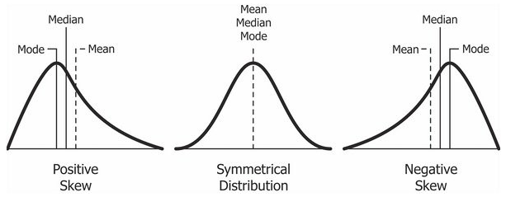

(3) **Kurtosis**: It is the measure of outliers present in the distribution.

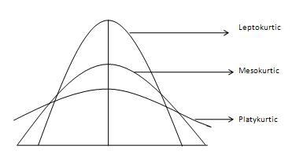

5) Dominant frequency (**TODO: What is the meaning of this feature?**)

- This feature is to capture the dominant peak with the most significant bandwidth within a considered frequency band.

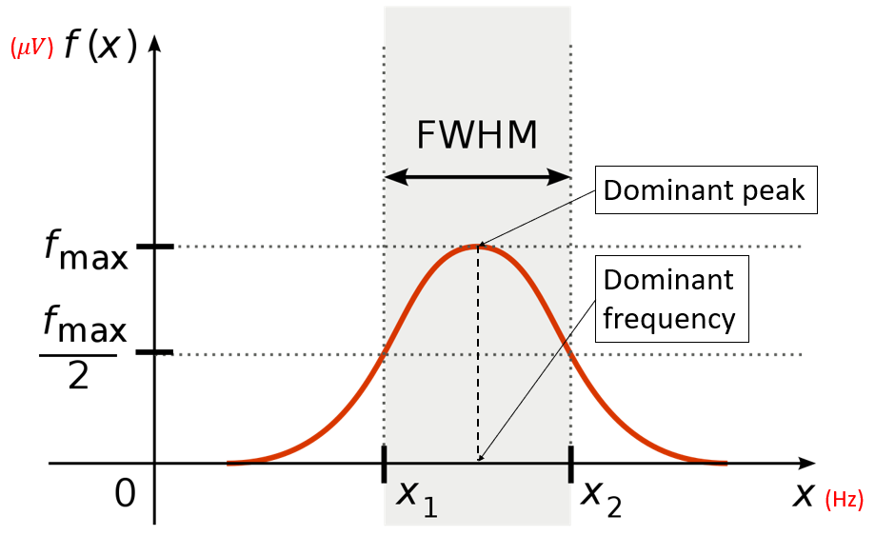

6) The average power of the dominant peak

- the average power on the full width half maximum (FWHM) band of a dominant peak

- It represents the significance of the dominant peak.

7) Center of gravity frequency (CGF)

$CGF=\frac{\left[\sum_{i}{}P(f_{i})×f_{i}\right]}{\left[\sum_{i}{}P(f_{i})\right]}$

, where $f$ is frequency and $P(f_{i})$ is the estimated power spectral density.

8) Frequency variability (FV)

- This feature is the variance of the frequency in the defined frequency band.

9) The combination of EEG activities

(1) $(θ+α)/β$

(2) $α/β$

(3) $(θ+α)/(α+β)$

(4) $θ/β$

• All four showed an increase in the ratio of slow wave to fast wave EEG activities over time.

• $(θ+α)/β$ showed a larger increase. The results have implications for detecting fatigue.

10) Relative power spectral density value for each 1 Hz bin from 1 Hz to 40 Hz

• Why? to select proper features among them

• Result? For the sleep deprived condition, the inaccuracy is 8-14 %

[Reasons to select each feature]

* Time-domain features
  + **Mean**: We can know the average voltage size of the specific window or the designated range. This feature value could be used to check the time when the EEG signal showed an unusual change.
  + **Standard deviation**: We can know the voltage size distribution in the specific window or the designated range. This feature value could be used to get the size of EEG value variation.
  + **Median**: We can know the principal EEG voltage size in the specific window or the designated range. This feature shows the value that can be represented in the corresponding interval without being influenced by the bias.
  + **75th percentile**: the median of the top 50 percentile with high voltage in one group. This feature shows the value that can be represented by the top 50% in the corresponding interval without being influenced by the bias.
  + **Skewness**: You can see the biased level of values in the interval. This feature shows the degree of deviation from the normal state voltage. When a person is active or clearly awake, EEG value could be often changed fastly and irregularly. Meanwhile, when a person is sleepy, the variable size of EEG value could be reduced, so the skewness value is close to 0.
  + **Kurtosis**: You can see the size of outliers in the interval. Like skewness, when a person is sleepy, the variable size of EEG value could be reduced, so the kurtosis value is close to 0.
* Frequency-domain features
  + **Dominant frequency**: We can know which wave band a person's dominant EEG signal belongs to.
  + **The average power of the dominant peak**: It represents the significance of the dominant peak. In other words, this feature shows the degree of signal convergence near the frequency. The stronger the average power of the dominant peak is, the higher the representative of the frequency is.
  + **Full width half maximum (FWHM) band**: We can know if the power is evenly distributed within the waveband.
  + **Center of gravity frequency (CGF)**: Based on voltage power, CGF calculates the frequency that can be regarded as the center frequency. This feature could be an alternative to the dominant frequency.
  + **Frequency variability (FV)**: This feature is the variance of the frequency in the defined frequency band. It can show the frequency distribution of the EEG signal.
  + $(θ+α)/β$: This feature shows the ratio of the wake + sleep N1 state to the active state. We can see the possibility of a person falling into drowsiness. The higher the value of this feature is, the higher the probability of the person is falling into drowsiness.
  + $α/β$: This feature shows the level of inactivity. The higher the value of this feature is, the higher the probability of the person is falling into drowsiness.
  + $(θ+α)/(α+β)$: This feature shows the ratio of the wake + sleep N1 state to the wake + active state. We can see the possibility of a person falling into drowsiness. The higher the value of this feature is, the higher the probability of the person is falling into drowsiness.